IAA-BR-16-0S-0P  
  
Paper Title CubeSat Frame Design - Petal Model  
  
Felipe Lima Mahlmeister[1]*, Rodrigo Alvite Romano*, Vanderlei Cunha Parro*, Rafael Corsi Ferrão*, Sergio Ribeiro Augusto*, Saulo Finco**, Silvio Manea***.

This summary deals with the development of a modular structure with conceptual focus on the disposal of PCBs (printed circuit board) in a CubeSat, where instead of the traditional format in which the cards are stacked inside, the electronic boards are positioned in the hub side in order to achieve greater internal space for payloads, as well as facilitating the access of PCBs during assembly and testing. This concept was titled as "petal model." The proposed structure was created according to the needs of the various groups taking part in the project. The modeling of the structure was carried out through a graphical modeling software where we adapted our concept according to the international standard specification for CubeSats. The parameters verified were weight, dimensions and materials, amongst others. Throughout the development, several prototypes were built in order to verify the technical feasibility of the proposal, enabling improvements to be incorporated in the structure. Comparisons of design and payload volume between the model and the current model were held. From this study it becomes clear that it is an interesting model and very competitive in the conceptual aspect, but for the reliability of that there is the need for further studies such as vibration, thermal and efforts.

Organização do trabalho:

Quantas paginas? Proximo de 12, com 2 colunas por pagina.

|  |  |  |  |  |  |
| --- | --- | --- | --- | --- | --- |
| Spec | Parameter | Requirement | Tolerance | Risk | Compliance |
| 1 | Cube Size (see CDS) | 100x100x113 mm | ±0.1 mm | L | AI |
| 2 | Protrusion | 6.5 mm | Max | L | AI |
| 3 | Modularity | 1,2,3 U | N/A | M | AIS |
| 4 | Mass | 200 g | Max | M | AI |
| 5 | Mouting Points | ? | Min | M | A |
| 6 | Vibration Test | FEI / ITA | Survive | M | AT |
| 7 | Ease of Acess  (integration) | Easy | N/A | H | AI |

|  |  |  |  |  |  |
| --- | --- | --- | --- | --- | --- |
|  | CubeSat Cal Poly | CubeSat Mauá (solidworks) | CubeSat Mauá (real) | Cubesat shop | Cubesatkit |
| Width [mm] | 100.0 |  |  |  |  |
| Length [mm] | 100.0 |  |  |  |  |
| Weight [g]  (sem chapinhas) | 1330 | 164.93 |  | 83 (medido solidworks) | 145.63 (medido solidworks) |
| (com chapa int) |  | 201.07 | 210 | 100 (site) | 62+132+49 = 243 (site) |
| (com chapa int + ext) |  | 340 | 348 |  |  |

Major Headings

Major Headings must be in Title Case and Bolt, Times New Roman 12 or similar, in left side.

1. Subheadings

Subheadings are bolted and in italic style, placed flush on the left band margin of the column.

Sub-subheadings

Sub-subheadings are underlined and indented

Style Guide

1. Acronyms

Always use the full title followed by the acronym to be used..

2. References

List and number all the bibliographical references at the end of the full text, in the order of appearance [1]

3. Equation Numbers

When numbering equations, enclose numbers in brackets and place flush right with the right band margin of the column.

 [1]

4. Illustrations and Captions

It is important to remember that all artwork, captions, figures, graphs and tables will be reproduced exactly as you submitted them. (Company logos and identification numbers are not permitted on your illustrations).

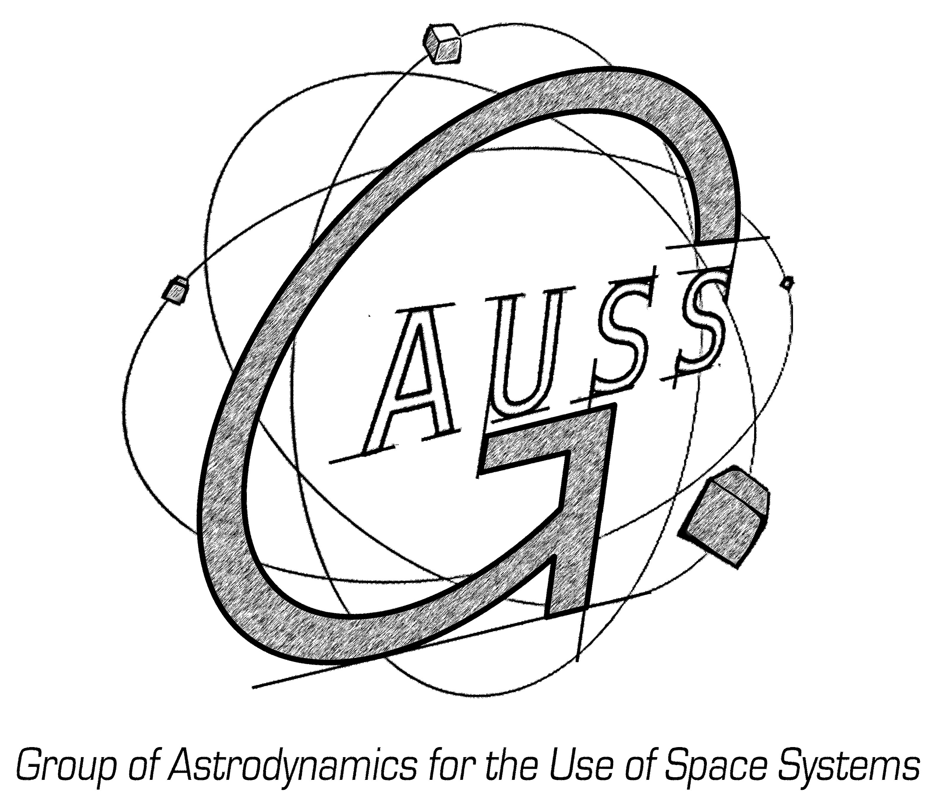

Fig. 1. Title of the figure, left justified, subsequent text indented. Place figures as close as possible to the first references to them in the manuscript. Use only black and white image. Font: Times New Roman 9.5.

5. Graph Lines, Drawings and Tables

Use black ink on white manuscript and ensure that they remain still readable.

|  |  |
| --- | --- |
| Xxxx | Yyyy |
| ABC | ~30 SI units |
| DEF | ~14 SI units |
| Total | ~44 SI units |

Table X. Title of table, left justified, subsequent text indented. Heading centered. Do not use vertical lines within the table..

5. Captions, Graph Axes, Legends

Captions, graph axes, legends, etc. should be large enough to remain readable.

6. Footnotes, Symbols and Abbreviations

Footnotes should be cited using numbers. Use only standard symbols and abbreviations in text and illustrations.

7. Page Numbers

Indicate page numbering at the top of each page with outside alignment.

References

[1] Author, Co-Authors: *Title*, YEAR, Journal Number, pages 12-13,

1. * Instituto Mauá de Tecnologia, Brazil, [felipe.mahlmeister1@gmail.com](mailto:felipe.mahlmeister1@gmail.com)

   ** Centro de Tecnologia da Informação Renato Archer

   *** INPE - Instituto Nacional de Pesquisas Espaciais